***Ansible Tower Installation:***

1. Download free trail version Ansible tower
2. 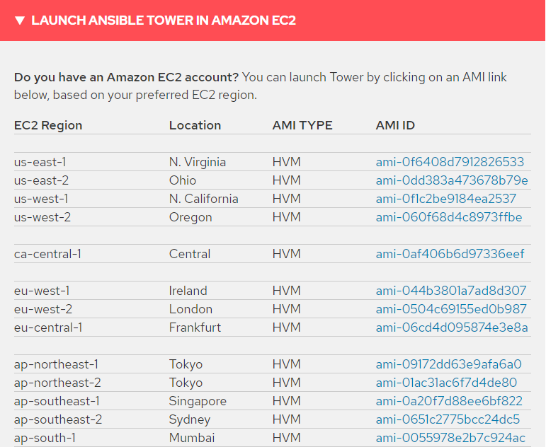
3. Select the region
4. Launch the instance EC2 – with 4GB ram and choose the region 2a and enable subnets
5. Take the volume 20GB
6. While connecting the instance in git bash instead of “**root**” change the user name **“centos**”
7. Copy the instance public ip and launch in webpage
8. Go for advance settings processed unsafe
9. Select the option
10. 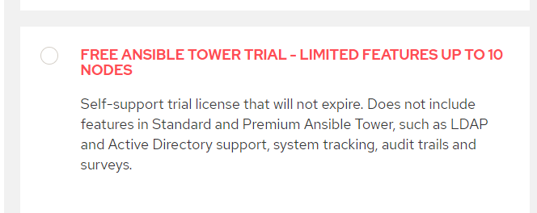
11. Fill the details create the login
12. Download the license key file
13. Browser the donload lic key file and login

***Project Creation:-***

1. 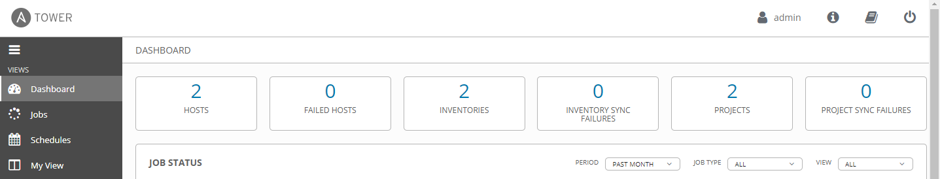
2. Go to projects
3. Creat a project
4. 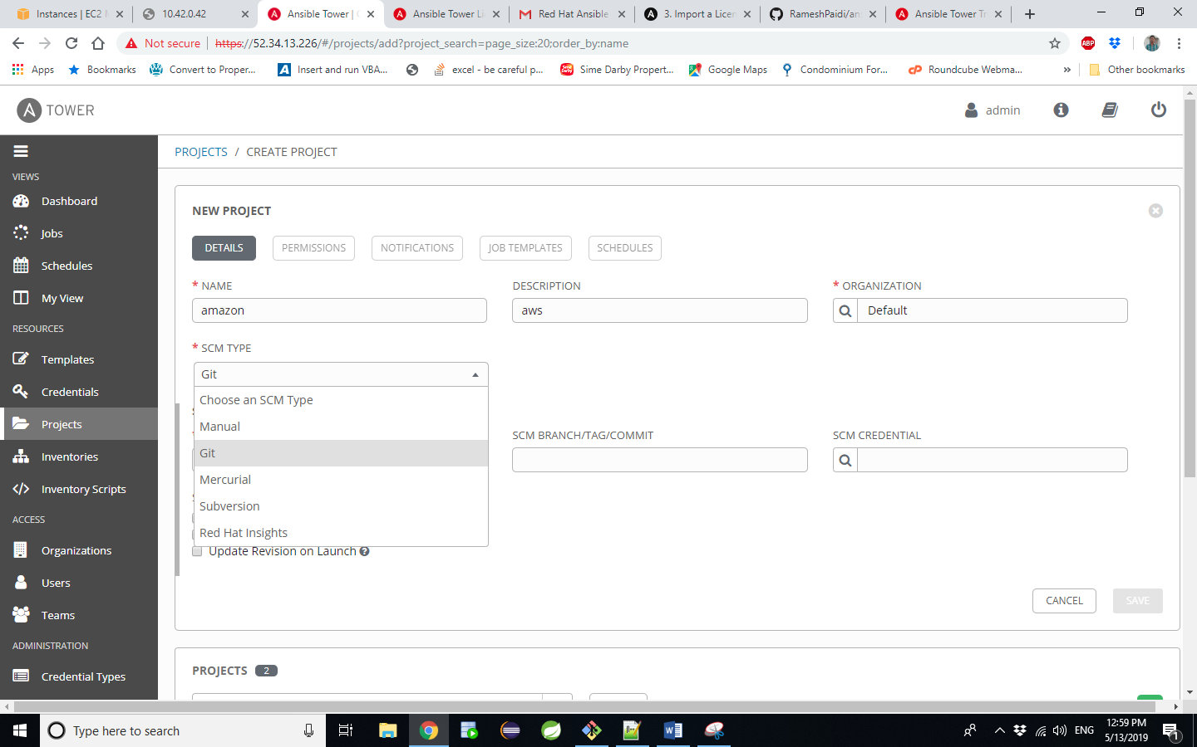
5. Copy the repository URL in SCM text box
6. Select the radio button “ update revision on launch”
7. Save and exit
8. Refresh the project for the latest updated file versions
9. Go to the dash board click on inventories
10. Choose the inventory name and description save and exit
11. Go to hosts and create a host
12. Give the private IP of node as a host name and save
13. Got credentials add new credential give the details as below
14. 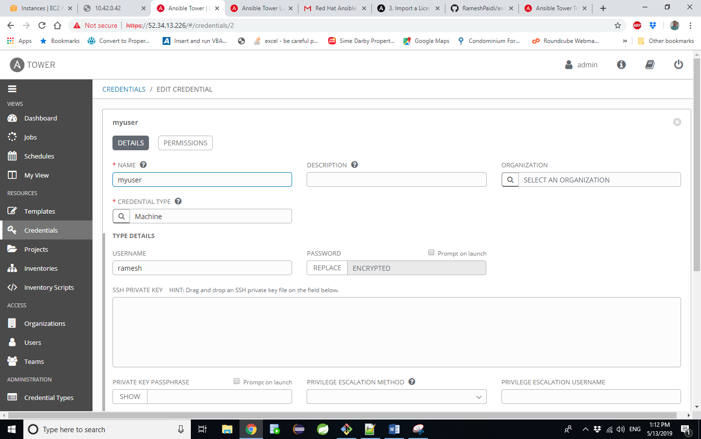
15. Go to templates
16. Create a new template and fill the details
17. 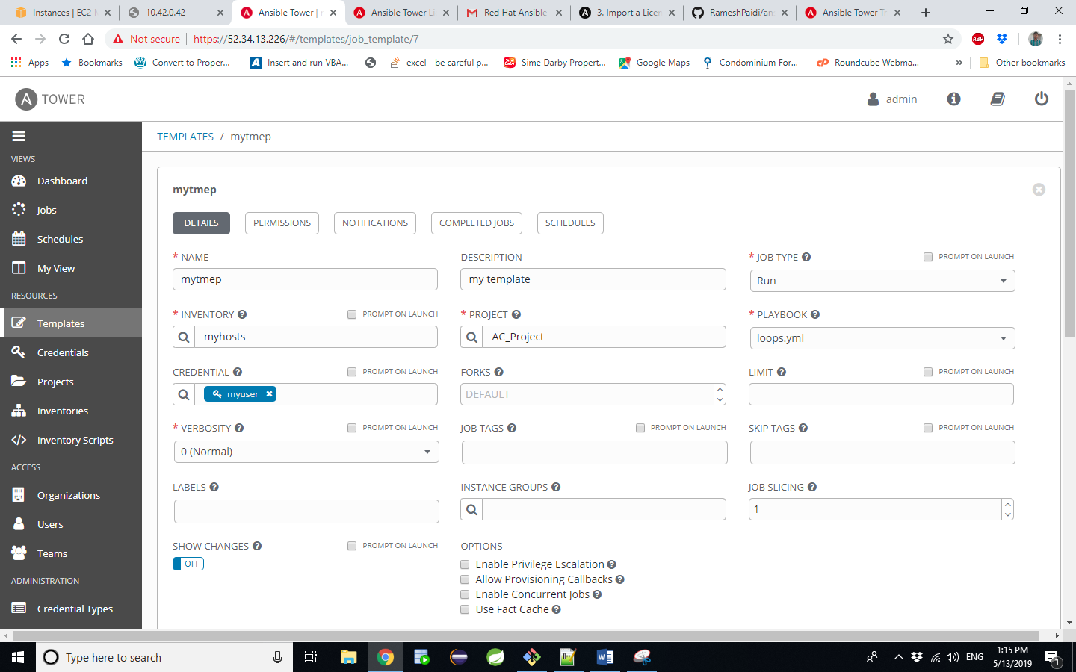
18. Give the details as shown above
19. 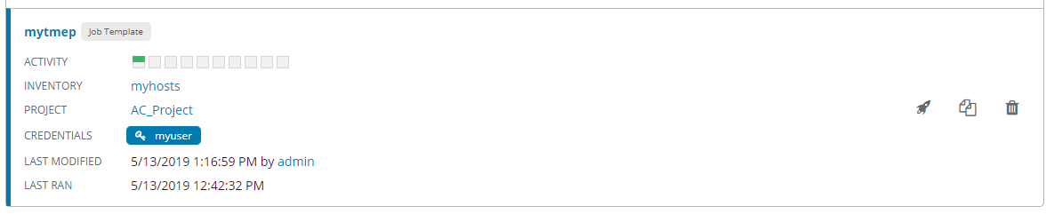
20. Run the project.